# Department of Software Engineering

**CS-114: Fundamentals of Programming**

**Class:** BE(SE)-11B

Lab 05: Conditional Statements and Loops

**Date:** November17, 2020

**Time:** 2:00 pm -5:00 pm

**Instructor:** Dr. Hashir Kiani

**Lab Engineer:** Ms. Sara Mehmood

**Lab 05: Selection and Iteration**

**Objectives**

In this lab the students will learn and practice to develop the understanding of python selection and loops statements.

**Tools/Software Requirement**

Python IDLE

**Description**

Follow the lab manual step by step. As you proceed, you will be asked to add screenshots/snaps of your results inside the provided output windows within this manual for grading purposes.

**Comparison \ Relational Operators**

These operators compare the values of two operands and return True or False. A combination of two operands and an operator is called a conditional statement. Basic comparison \ relational operators available in Python are:

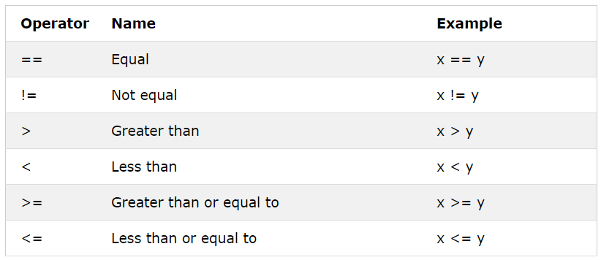

**Logical Operators**

Logical operators are used to combine two or more conditional statements and return True or False. Basic logical operators available in Python are:

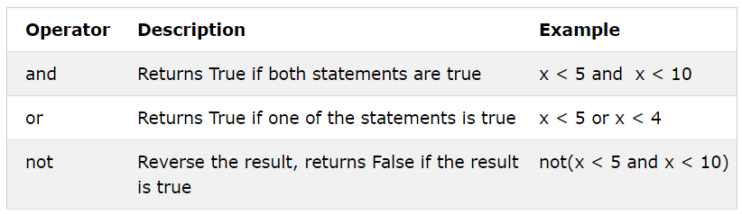

**Conditional Statement**

Conditional statements perform different computations or actions depending on whether a specified condition evaluates to True or False. It uses the “if” keyword to check the condition. The condition of the “if” statement ends with a colon ( : ). The “elif” (short for Else-If) keyword can be used together with the “if” keyword to check additional conditions if the first “if” condition is False.Finally, if you want to execute a set of statements when no condition is True you can use the “else” keyword. See the example below for a clear understanding of the “if-elif-else” statement.

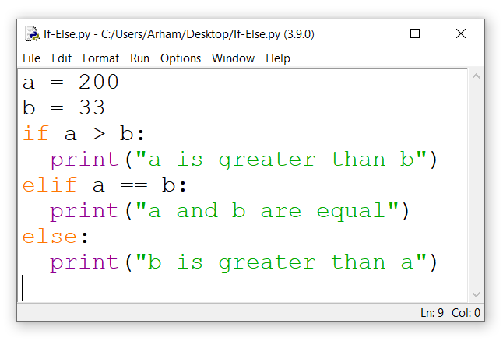

You can use multiple “elif” keywords with the “if” keyword as shown in the following example.

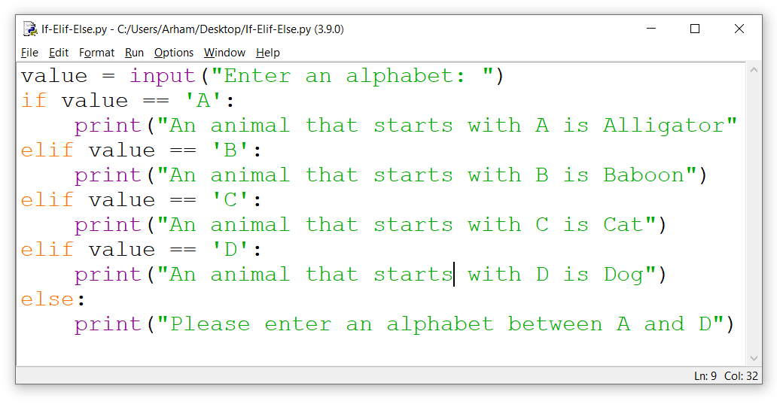

All statements that you want to execute when the condition is True should be written with a single Indentation.

**Iteration**

Iteration or looping is used to execute a block of statement a certain number of times or until a condition is met. The “for” or “while” keywords are used for iteration. The “for” loop is used when we want to execute a block of code a certain number of times. The “while” loop is used when we want to execute a block of code until a condition is met. See the example below for a clear understanding of the “for” loop.

for i in range(10): # This statement executes the indented block of code 10 times.

print(i)

else:

print(“The loop has ended”)

See the following example for a while loop.

i=0 # for a while loop you need to initialize your conditional variable

while i<10: # This statement executes the indented block of code until the while condition remains true.

print(i)

i=i+1

else:

print(“The loop has ended”)

**Lab Tasks:**

Using only the programming techniques that you have learned so far, perform the following tasks.

Note: All the tasks of this lab should be performed in Python scripted mode only. You should use sensible and self-explanatory names for the variables you are using. Please add comments to your code to explain what you are doing. Also use print statements to explain your program as well as inputs and outputs.

1. Write a python program that takes an integer input from the user which is the number of terms. The program then displays the Fibonacci series up to the number of terms entered by the user. The Fibonacci series is 0,1,1,2,3,5,8,13,21,34,…….. The next term in Fibonacci series is given by the sum of the previous two terms.

Example program:

Please input the number of terms: 3

The first 3 terms of Fibonacci series are: 0, 1, 2

Please input the number of terms: 10

The first 10 terms of Fibonacci series are: 0, 1, 2, 3, 5, 8, 13, 21, 34, 55

**Solution:**

y=int(input("Please input the Number of terms :"))  
a=0  
b=1  
print("The first",y,"terms of Fibonacci series are :" , a ,end=", ")  
print(b,end=", ")  
for x in range(2,y):  
 c = a+b  
 a = b  
 b = c  
 print(c ,end=", ")

"C:\Users\Moavia computer\PycharmProjects\pythonProject\venv\Scripts\python.exe" "C:/Users/Moavia computer/PycharmProjects/pythonProject/main.py"

Please input the Number of terms :10

The first 10 terms of Fibonacci series are : 0, 1, 1, 2, 3, 5, 8, 13, 21, 34,

Process finished with exit code 0

1. Write a python program that takes two inputs from a user and then creates a 2-D list that has number of rows equal to the first input and number of columns equal to the second input. The elements of the 2-D list are obtained by multiplying the column number and row number.

Example program:

Please input the number of rows: 2

Please input the number of columns: 3

The 2-D list is:

1 2 3

2 4 6

**Solution:**

q = int(input("Enter the number of rows : "))  
p = int(input("Enter the number of coloumns :"))  
print("The 2-D list is :")  
for t in range(1,q+1):  
 print(t,end=" ")  
 for k in range(2,p+1):  
 print(t*k,end= " ")  
 print("")

"C:\Users\Moavia computer\PycharmProjects\pythonProject\venv\Scripts\python.exe" "C:/Users/Moavia computer/PycharmProjects/pythonProject/main.py"

Enter the number of rows : 2

Enter the number of coloumns :3

The 2-D list is :

1 2 3

2 4 6

Process finished with exit code 0

1. Write a python program that takes a binary number as input and displays the decimal equivalent of that binary number. To convert a binary number to decimal we do the following: For example 1011 can be converted by finding $1×2^{0}+1×2^{1}+0×2^{2}+1×2^{3}=11$.

Example program:

Please input abinary number: 1001010011

The decimal equivalent of the above binary number is: 595

Please input a binary number: 101010101

The decimal equivalent of the above binary number is: 341

**Solution:**

x=int(input("Enter a binary number :"))  
y=0  
j=0  
while x!=0:  
 f = x%10  
 y = y + f * pow(2,j)  
 x = int(x/10)  
 j=j+1  
print("The Decimal equivalent of above number is :",y)

"C:\Users\Moavia computer\PycharmProjects\pythonProject\venv\Scripts\python.exe" "C:/Users/Moavia computer/PycharmProjects/pythonProject/main.py"

Enter a binary number :101010101

The Decimal equivalent above number is : 341

Process finished with exit code 0

1. Write a program that takes a number as input and finds the square root of that number and displays the result correct to 4 decimal places. Do not use any in-built functions like the sqrt function from math library. You can only use normal mathematical operations in python.

Example program:

Please input a number: 81

The square root of the above number is: 9

Please input a number: 175

The square root of the above number is: 13.2288

**Solution:**

for i in range (1,3):  
 x = int(input("Enter any number : "))  
 y = x/2  
 z = y + 1  
 while y!=z:  
 c = x/y  
 z = y  
 y = (y + c)/2  
 if x%y==0:  
 y = int(y)  
 print("The square root of the above number is :" , y)  
 else:  
 z = format(y,".4f")  
 print("The square root of the above the number is :" , z)

"C:\Users\Moavia computer\PycharmProjects\pythonProject\venv\Scripts\python.exe" "C:/Users/Moavia computer/PycharmProjects/pythonProject/main.py"

Enter a number: 677

The square root of the above number is: 26.0192

Enter a number: 16

The square root of the above number is: 4

Process finished with exit code 0

1. Write a program that takes a string as input and displays the number of characters in that string.

Example program:

Please input a string: hello

The above string has 5 characters.

Please input a string: what is your name?

The above string has 18 characters.

|  |  |
| --- | --- |
|  |  |

**Solution:**

x=input("Please input a string :")  
y=0  
for j in x:  
 y += 1  
print('The above string has',y,'characters')

"C:\Users\Moavia computer\PycharmProjects\pythonProject\venv\Scripts\python.exe" "C:/Users/Moavia computer/PycharmProjects/pythonProject/main.py"

Please input a string :hello world

The above string has 11 characters

Process finished with exit code 0

1. Write a program that takes a list of 20 integers as input and removes all the even numbers from the list and then displays the result. You should take the input in a list.

Example program:

Please input 20 integers separated by a space:5111216132435162798341014182221

After removing even numbers the above list is: [5,11,13,35,1,7,9,3,21]

|  |  |
| --- | --- |
|  |  |

**Solution:**

list1 = []  
x = input("Please input 20 numbers seperated by space :")  
list1 = x.split( )  
y = len(list1)  
list2 = []  
for j in range (y):  
 c = int(list1[j])  
 if c%2 != 0:  
 list2.append(c)  
print("After removing even numbers above list is :",list2)

"C:\Users\Moavia computer\PycharmProjects\pythonProject\venv\Scripts\python.exe" "C:/Users/Moavia computer/PycharmProjects/pythonProject/main.py"

Please input 20 numbers seperated by space : 1 2 3 4 5 6 7 8 9 10 11 12 13 14 15 16 17 18 19 20

After removing even numbers above list is : [1, 3, 5, 7, 9, 11, 13, 15, 17, 19]

Process finished with exit code 0